Day 1 Editing

Steps to Editing With iMovie

Turn on computer
-Button back left

Click on your class periods user (period 1 for class period #1, etc.)

Open iMovie (purple star)
-Button on screen at the bottom – or – F4 in apps

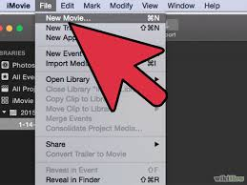
Create a new movie and new event
-Click on File (top left screen), create new movie - label F ___ P ___
-Click on File (top left screen), create new event
– label F ___ p ___

Plug USB in the back of your computer
-upload to iMovie

