www.classwithlyon.com

AP Studio Art
Mrs. Lyon

Studio Art: Drawing, 2-D, & 3-D

Syllabus
This is a year long course designed for students who are seriously interested in the practical experience of art and wish to develop mastery in drawing, 2-D, and/or 3-D. Students will focus on either the drawing, 2-D, and/or 3-D portfolio. In AP studio art the exam is based on a portfolio and not a written exam, though students will be writing about their art, the writing enhances the work. While students are building their portfolio they will experience a variety of concepts, techniques, and approaches designed to help them demonstrate their ability as well as their versatility with techniques, problem solving, and ideation. Students will develop a body of work for their concentration that investigates an idea of personal interest to them that has a strong underlying visual idea that will grow out of a coherent plan of action or investigation . This is a rigorous college level course that requires a strong commitment from highly motivated students. The course:
1) Is a year long investigation of all three aspects of the portfolio - quality, concentration, and breadth(see diagram on page 2).
2) Is designed for students to develop mastery in concept, composition, and execution in drawing, 2-D, and/or 3-D.
3) Empowers students to develop a cohesive body of work investigating a strong underlying visual idea in drawing, 2-D, and/or 3-D that grows through the units outlines each week(see pages 7-16).
- Teaches a variety of concepts and approaches in drawing, 2-D, and/or 3-D so that the student is able to demonstrate their range of abilities and versatility with techniques(see page 5 - 6) , problem solving(see Assignment List Appendix 6) , and ideation(see Developing Your Concentration Appendix 5).
- Emphasizes making art as an ongoing process that involves students to make informed and critical decisions through individual, peer, and group critiques. Then taking that experience and transferring it to creating new art from what the artist gained during the critique process(see AP Student Self & Peer Scoring Rubric Appendix 3).
- Teachers students to understand artistic integrity as to what constitutes as plagiarism(see the section below in course goals page 6-7 and course outline page ).
Course Goals
To encourage creativity, personal voice, while applying the expectations of each portfolio as listed below.
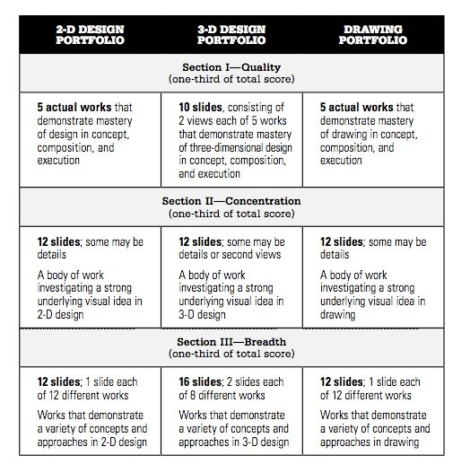
To emphasize making art as an ongoing process that challenges students to make informed and critical decisions while developing their art to a level of mastery.
To develop technical versatility and skills while using the visual elements and principles such as in drawing, 2-D, & 3-D.

AP Portfolio
AP Studio Art addresses three major concerns: (Section 1) a sense of quality in a student’s work, ( Section II) the student’s concentration on a particular visual interest or problem: and (Section III) the student’s need for breadth of experience. AP Studio art should reflect these three areas of concern: quality, concentration, and breath.

Quality
Quality refers to the mastery of design principle that should be apparent in the concept, composition and execution of the works, whether they are simple or complex. There is no preferred(or unacceptable) style or content. Quality allows the student to chose their best works to exhibit a synthesis of form, technique and content that demonstrate mastery of design in concept, composition and execution for drawing, 2-D design, or 3-D design depending on the portfolio. The works submitted may come from the Concentration and/or Breadth sections, but they do not have to. They may be a group of related works, unrelated works, or a combination of related and unrelated works.
Concentration
Concentration is another word for focus in thinking about the AP Portfolio. For the concentration student’s will develop a body of work that is based on a planned investigation of an idea that is of personal interest to them in visual form. Students will use informed devision making and problem solving skills in an ongoing process to develop and select the 12 pieces of work for their concentration. Works describing an in-depth exploration of a particular concern for drawing, 2-D design, or 3-D design. Students are asked to respond to the following: 1) clearly and simply state the central idea of your concentration. 2) Explain how the work in your concentration demonstrates your intent and the exploration of your idea. You may refer to specific images as examples. The responses themselves are not scored as pieces of writing, they do provide critical information for evaluating the artwork. They should be well written. Students are encouraged to formulate their responses to the first question when they start their concentration. Students are not allowed to submit the same images that they did in the breadth in their concentration, they are two separate categories.

Breadth
The breadth section think of the word variety. Student’s work in this section should demonstrate understanding of the principles of design, including unity/variety, balance, emphasis, contrast, rhythm, repetition, proportion/scale and figure/ground relationships. Successful works of art require the integration of the elements and principles of design; student must therefore be actively engage with these concepts while thoughtfully composing their art. The work in this section should show evidence of conceptual, perceptual, and expressive development, as well as technical skill. Using all the knowledge students have gained about the art elements and principles of design will be applied to these three areas. A variety of concepts and approaches will be used by students to demonstrate their abilities with a versatile with technique, ideation, and problem solving. A variety of works that demonstrate understanding of principles of drawing, 2-D design, or 3-D design depending on the portfolio.

Homework
As in any college level course, students are expected to spend a substantial amount of time working on their art outside of class time. Homework will mostly be related to the sketchbook, in class art work, or maintaining a student online portfolio/website.

Open Studio
Will be after school during the week. Students are welcome to work on their art work from 3:15-5pm on days school is in session. There is also studio time in class when students are working on their projects and the teacher is either working with students individually.

Exhibitions/Competitions
Students are encourage to show their work in exhibitions throughout the year. An Annual Winter Art Show is held every December, the State Art Show is held in February, and the High School Gala Art Event is Held in February. Check out the art department calendar on the department website for more information about this throughout the year: department website here

Assignments/Evaluation
A list of assignments can be viewed on the class website (web would be here address here) by going to the AP tab (see list of assignments Appendix 6). Assignments have due dates and it is important that students let their instructor know when they will not be able to make it to class so students can make-up missed class time.

Online portfolio
Students are expected to post all their work to an online portfolio. Instructions in class will be given how to create and upload images to the online portfolio. This portfolio will serve as a record of their work to store images and for students to have a digital achieve. A camera and computers will be provided in class for students to work on their online portfolios. Make sure the art work you are posting is original. It can be inspired by another artist, however you need to make the art work your own and not a copy.

Ways to work in your sketchbook
Sketchbook assignments will be given in class. Some work will be done in class and some sketchbook assignments will be given as homework. The sketchbook is an integral part of creating, by allowing students to work out their ideas before completing a final piece of work.

Mini Lessons
Are lessons given at the beginning of class that address a variety of concepts, skills, techniques, and approaches designed to help students complete their AP portfolio. The mini-lessons correlate with the theme of the weekly units(see semester plan for more details and the charts below).
Drawing
Techniques in Mini-Lessons: | Mediums students have access to in class:
stippling | shading pencils
cross-hatching | colored pencils
blending | markers
mixing | paint - watercolor, oil, & acrylic
color theory | scratch board
additive and subtractive processes | oil pastels
mixed media tricks & experiments | Chalk
theme | charcoal
 | mixed media - collage
 | ink

2-D
Techniques in Mini-Lessons: | Mediums students have access to in class:
rule of thirds | lens based digital media
digital media | cardboard
print making | scratch board
theme | textiles
 | collage media(adhesives, paper, objects)
 | drawing materials
 | wet media(paint, ink, dyes)
 | dry media(pastels, pencils, charcoal)

3-D
Techniques in Mini-Lessons: | Mediums students have access to in class:
space - negative & positive | clay
cutting | wire
sculpting | cardboard
hand shaping/forming | found objects
creating joints without glue | old books
 | metal
 | paper
 | wood
 | glass

Inspirational Moments
Are also at the beginning of class and are designed to provide inspiration for the students to create their art. Sometime it might be a student sharing their art work, reading a quote, a section from a book, current art news, or listening to a song.
Ethics, Artistic Integrity and Plagiarism
Any work that makes use of (appropriates) photographs, published images and/or other artists’ work must show substantial and significant development beyond duplication (lesson addressed in semester plan on page 8). This is demonstrated though manipulation of the formal qualities, design and/or concept of the source. The student’s individual “voice” should be clearly evident in the work. It is unethical, constitutes plagiarism, and often violates copyright law simply to copy an image(even in another medium) that was made by someone else and presents it as one’s own.
Digital images of student work that are submitted for the Breadth and Concentration sections of the portfolio may be edited. However, the goal of image editing should be to present the clearest, most accurate representation of the student’s artwork, and to ensure that images meet the requirements of the Digital Submission Web application. When submitting their portfolios,students must indicate their acceptance of the following statement: “ I hereby affirm that all works in this portfolio were done by me and that these images accurately represent my actual work.”

Supplies and Fees
Students are required to pay a $15- fee per term for AP art on top of the fee for the AP exam. In return students have access to all art supplies in the class and are given a sketch book that they are required to work in for their homework assignments.

Semester Plan
Week & Notes | Assignment Concepts | Assessment | Sketchbook & Online Portfolio
Week 1  - students will receive sketchbooks and folders  - begin taking pictures of student work and organizing files on class laptop | - Learn how to critique art work using the AP rubric(3D,2D, & drawing)  - Learn the expectations for all 3 of the portfolios - drawing, 2-D design, and 3-D  - Prep surface to work on for art  - in class studio time | - Assess where each student is at with their portfolio - create individual calendars for each student(AP progress form - see appendix for this form)  - Each student will photograph their completed works | - Pick one of the assignments from the class website: a link to the class website would be here, however that includes the teacher’s name so it is kept from this version  - Complete a sketch of one of those assignments
Week 2  - work with students to figure out what open studio time outside of class will look like and what days students need to most time after school in class | - start projects on AP progress form  - being working on prepared surfaces and re-working old art pieces(the ones you hate)  - in class studio time | - a project plan completed for at least one of more project ideas  - a list of projects or pieces to rework with notes attached on what the student wants to change about the piece | - Students will use a shared Google Doc to critique each others work on their online portfolios that they create using their own website in class
Week 3  - review art elements & principles of design relevant to each student’s individual needs  - class focus unity & variety | - continue working on projects that have been listed out on AP progress form  - mini-lessons before class - artistic integrity & plagiarism, moving beyond duplication and creating work that is yours.  - in class studio time | - turn in at least one completed or re-worked piece by the end of this week, that relates to the class focus, unity & variety (see the list of assignments in the appendix below)  - evaluate a peers work based on the AP rubric(group critique), make sure your own work has been evaluated two times by peers, one self-evaluation, then turn in work with peer and self-evaluation to teacher | - Students continue to update online portfolio(website) as they complete work  - Pick one of the assignments from the class website that addresses unity & variety: www.classwithlyon.com  - Complete a sketch of one of those assignments
Week 4  - artist statements | - start a new project from the AP list of projects, using the progress form as a guide  - mini-lessons before class about how to write an artist statement about one work of art  - in class studio time | - a project plan completed for at least one of more project ideas | - Complete an artist statement in your online portfolio about your favorite work of art thus far.
Week 5  - during PTC have an AP Art meeting  - what type of portfolio should you work on? 2-D, drawing, or 3-D  - class focus: emphasis | - mini-lessons before class, review artist statements and share  - re-address the types of portfolios  - in class studio time | - turn in at least one completed or re-worked piece by the end of this week that addresses emphasis  - evaluate a peers work based on the AP rubric(group critique), make sure your own work has been evaluated two times by peers, one self-evaluation, then turn in work with peer and self-evaluation to teacher | - Pick one of the assignments from the class website from the emphasis section: www.classwithlyon.com Complete a sketch of one of those assignments
Week 6 | - in class studio time  - inspiration moments at the beginning of class | - at the end of the week review individual AP progress form | - Upload work to website(online portfolio)
Week 7  - class focus rhythm | - mini-lessons before class, techniques and skills to help the group  - in class studio time | - turn in at least one completed or re-worked piece by the end of this week that focuses on rhythm  - evaluate a peers work based on the AP rubric, make sure your own work has been evaluated two times by peers, one self-evaluation, then turn in work with peer and self-evaluation to teacher | Pick one of the assignments from the class website that addresses rhythm: www.classwithlyon.com Complete a sketch of one of those assignments
Week 8 | - in class studio time  - inspiration moments at the beginning of class | - at the end of the week review individual AP progress form with the teacher | - Double check to make sure students are documenting work and adding work to their online portfolio(website)
Week 9  - class focus balance | - mini-lessons before class, techniques and skills to help the group  - review - artistic integrity & plagiarism, what happens is you recreate a work of art and don’t change it at all?  - in class studio time | - turn in at least one completed or re-worked piece by the end of this week that addresses balance  - evaluate a peers work based on the AP rubric(group critique), make sure your own work has been evaluated two times by peers, one self-evaluation, then turn in work with peer and self-evaluation to teacher | - Pick one of the assignments from the class website that deals with balance: www.classwithlyon.com Complete a sketch of one of those assignments
Week 10 | - in class studio time  - inspiration moments at the beginning of class | at the end of the week review individual AP progress form with the teacher | - Upload work to website(online portfolio)
Week 11  - class focus for contrast | - mini-lessons before class, techniques and skills to help the group remember contrast  - in class studio time | - turn in at least one completed or re-worked piece by the end of this week that deals with contrast  - evaluate a peers work based on the AP rubric, make sure your own work has been evaluated two times by peers, one self-evaluation, then turn in work with peer and self-evaluation to the teacher | - Pick one of the assignments from the class website from the choices in the contrast section: www.classwithlyon.com  - Complete a sketch of one of those assignments
Week 12 | - in class studio time  - inspiration moments at the beginning of class | - at the end of the week review individual AP progress form  - Complete Developing your concentration worksheet | - Upload work to website(online portfolio)
Week 13  - class focus repetition | - mini-lessons before class, techniques and skills to help the group learn repetition  - in class studio time | - turn in at least one completed or re-worked piece by the end of this week that addresses your understanding of repetition  - evaluate a peers work based on the AP rubric, make sure your own work has been evaluated two times by peers, one self-evaluation, then turn in work with peer and self-evaluation to the teacher | - Pick one of the assignments from the class website about repetition: www.classwithlyon.com Complete a sketch of one of those assignments
Week 14 | - in class studio time  - inspiration moments at the beginning of class | at the end of the week review individual AP progress form | - Upload work to website(online portfolio)
Week 15  - Prepare work for the winter art show  - class focus proportion/scale | - mini-lessons before class, techniques and skills to help the group learn proportion/scale  - Matting work, labeling, and hanging a body of work.  - All AP students art expected to hand at least three pieces or more of their concentration for the Winter Art Show.  - in class studio time | - turn in at least one completed or re-worked piece by the end of this week that deals with proportion/scale  - evaluate a peers work based on the AP rubric(in the art show), make sure your own work has been evaluated two times by peers, one self-evaluation, then turn in work with peer and self-evaluation to the teacher | Pick one of the assignments from the class website from the proportion/scale section: www.classwithlyon.com Complete a sketch of one of those assignments
Week 16  - Winter Art Show | - in class studio time  - inspiration moments at the beginning of class | at the end of the week review individual AP progress form | - Upload work to website(online portfolio)
Week 17  - Winter Break  - class focus figure/ground relationships  Home work for Winter Break, begin sketching out ideas for at least five pieces that you would like to do for your concentration | - mini-lessons before class, techniques and skills to help the group work on figure/ground relationships  - in class studio time | - turn in at least one completed or re-worked piece by the end of this week that addresses your understanding of figure/ground relationships  - make a list of projects each student will need to complete over the break, this will be on an individual bases for each student depending on his/her progress | - Pick one of the assignments from the class website from the list of projects under figure/ground relationships section: www.classwithlyon.com  - Complete a sketch of one of those assignments
Week 18  - website information and passwords for students to upload images, either this month or next | - in class studio time  - inspiration moments at the beginning of class | at the end of the week review individual AP progress form & progress accomplished over the winter break with the teacher | - Upload work to website(online portfolio)
Week 19  - class focus conceptual, perceptual & expressive development | - mini-lessons before class, techniques and skills to help the group reflect on conceptual, perceptual & expressive development  - in class studio time | - turn in at least one completed or re-worked piece by the end of this week that is about conceptual, perceptual & expressive development  - evaluate a peers work based on the AP rubric, make sure your own work has been evaluated two times by peers, one self-evaluation, then turn in work with peer and self-evaluation to the teacher | Pick one of the assignments from the class website from the conceptual, perceptual & expressive development section: www.classwithlyon.com Complete a sketch of one of those assignments
Week 20 | - in class studio time  - inspiration moments at the beginning of class | at the end of the week review individual AP progress form | - Upload work to website(online portfolio)
Week 21  - class focus technical challenges | - mini-lessons before class, techniques and skills to help the group address each of their individual technical challenges  - in class studio time | - turn in at least one completed or re-worked piece by the end of this week where you worked on a technical challenge(s) for you  - evaluate a peers work based on the AP rubric, make sure your own work has been evaluated two times by peers, one self-evaluation, then turn in work with peer and self-evaluation to the teacher | Pick one of the assignments from the class website from the list of technical challenges: www.classwithlyon.com Complete a sketch of one of those assignments
Week 22  - Ben Lomond High School Art Gala Event | - in class studio time  - inspiration moments at the beginning of class | at the end of the week review individual AP progress form to document your progress(self-monitoring) | - Upload work to website(online portfolio)
Week 23 | - mini-lessons before class, start working on artist statement that encompasses your concentration  - in class studio time  - reminder about artistic integrity lesson before submitting final documents for the portfolio | - turn in at least one completed or re-worked piece by the end of this week  - evaluate a peers work based on the AP rubric, make sure your own work has been evaluated two times by peers, one self-evaluation, then turn in work with peer and self-evaluation to the teacher | - Pick one of the assignments from the class website: www.classwithlyon.com Complete a sketch of one of those assignments  - Upload completed artist statement online to your website
Week 24 | - in class studio time  - inspiration moments at the beginning of class | - at the end of the week review individual AP progress form with the teacher | - Upload work to website(online portfolio)
Week 25 | - mini-lessons before class, techniques and skills to help the group(  - in class studio time | - turn in at least one completed or re-worked piece by the end of this week  - evaluate a peers work based on the AP rubric, make sure your own work has been evaluated two times by peers, one self-evaluation, then turn in work with peer and self-evaluation to the teacher | - Pick one of the assignments from the class website: www.classwithlyon.com Complete a sketch of one of those assignments
Week 26 | - in class studio time  - inspiration moments at the beginning of class | at the end of the week review individual AP progress form(self-monitoring) | - Upload work to website(online portfolio)
Week 27 | - mini-lessons before class  - in class studio time | - turn in at least one completed or re-worked piece by the end of this week  - evaluate a peers work based on the AP rubric, make sure your own work has been evaluated two times by peers, one self-evaluation, then turn in work with peer and self-evaluation to the teacher | - Pick one of the assignments from the class website: www.classwithlyon.com Complete a sketch of one of those assignments
Week 28 | - in class studio time  - inspiration moments at the beginning of class |  | - Upload work to website(online portfolio)
Week 29 | - mini-lessons before class  - in class studio time | - turn in at least one completed or re-worked piece by the end of this week  - evaluate a peers work based on the AP rubric, make sure your own work has been evaluated two times by peers, one self-evaluation, then turn in work with peer and self-evaluation to the teacher | - Pick one of the assignments from the class website: www.classwithlyon.com Complete a sketch of one of those assignments
Week 30  - start gathering work to mail in  - remind students to have a current mailing address | - inspiration moments at the beginning of class  - in class studio time |  | - Upload work to website(online portfolio)
Week 31 | - mini-lessons before class  - in class studio time | - turn in at least one completed or re-worked piece by the end of this week  - evaluate a peers work based on the AP rubric, make sure your own work has been evaluated two times by peers, one self-evaluation, then turn in work with peer and self-evaluation to the teacher | - Pick one of the assignments from the class website: www.classwithlyon.com Complete a sketch of one of those assignments
Week 32 | - inspiration moments at the beginning of class  - in class studio time | at the end of the week review individual AP progress form | - Upload work to website(online portfolio)
Week 33 | - mini-lessons before class and review of artistic integrity & plagiarism, double checking each others work before submitting  - in class studio time | - evaluate a peers work based on the AP rubric and help at least one peer decide what work to submit for their portfolio and what work to remove, document and turn into the teacher | - Complete any unfinished work or revisit old pieces that you are not going to submit as part of your portfolio and see if you can rework them
Week 34 | - inspiration moments at the beginning of class  - in class studio time | at the end of the week review individual AP progress form
Week 35  All digital submissions due | - mini-lessons before class  - in class studio time

Appendix 1 - AP Progress Guide Form
AP Progress Guide Form
Students complete this form while they work on projects to determine their progress in the course.
Drawing - mark making
My concentration is _____________________________________________________________________________.

AP Portfolio
Concentration(12 pieces) | Title, Medium, Size | Date Completed
1)
2)
3)
4)
5)
6)
7)
8)
9)
10)
11)
12)

Breadth (12 pieces) | Title, Medium, Size | Date Completed
1)
2)
3)
4)
5)
6)
7)
8)
9)
10)
11)
12)

Reminders:
- Put a star * next to the five pieces of work that you are considering to send in for your quality.
- Make sure to photograph every piece of art on your list and include it in your folder on the class laptop.
- Make sure you can not see your name on your works of art, either the physical ones that you are sending in for your quality or in the photographs that you take.

2-D Portfolio
My concentration is _____________________________________________________________________________.

AP Portfolio
Concentration(12 pieces) | Title, Medium, Size | Date Completed
1)
2)
3)
4)
5)
6)
7)
8)
9)
10)
11)
12)

Breadth (12 pieces) | Title, Medium, Size | Date Completed
1)
2)
3)
4)
5)
6)
7)
8)
9)
10)
11)
12)

Reminders:
- Put a star * next to the five pieces of work that you are considering to send in for your quality.
- Make sure to photograph every piece of art on your list and include it in your folder on the class laptop.
- Make sure you can not see your name on your works of art, either the physical ones that you are sending in for your quality or in the photographs that you take.

3-D Portfolio
My concentration is _____________________________________________________________________________.

AP Portfolio
Concentration(6-12 pieces) | Title, Medium, Size | Date Completed
1)
2)
3)
4)
5)
6)
7)
8)
9)
10)
11)
12)

Breadth (12 pieces) | Title, Medium, Size | Date Completed
1)
2)
3)
4)
5)
6)
7)
8)

Reminders:
- Put a star * next to the five pieces of work that you are considering to send in for your quality. (Remember you don’t have to mail in your 3-D works)
- Make sure to photograph every piece of art on your list and include it in your folder on the class laptop.
- Take multiple shots of each piece to show, detail, different view points, etc. that show off the techniques and skills you demonstrated the best for that piece of art.

Appendix 2 - Artist Statement Form
Artist Statement Form
Artist Statement Form Concentration & Breadth (5 pieces you want to send in) make it specific for each AP studio & artist statement ( 2 pages).

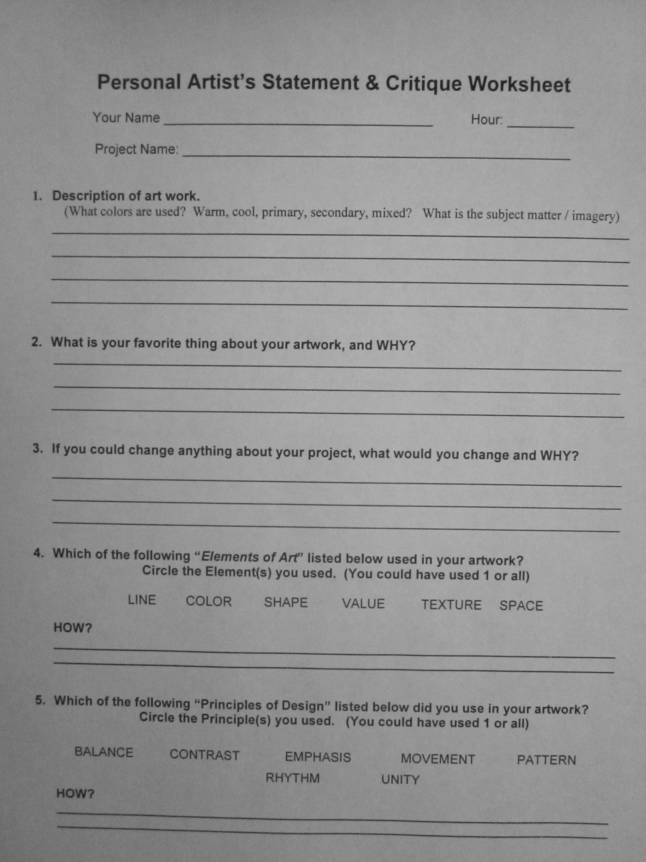

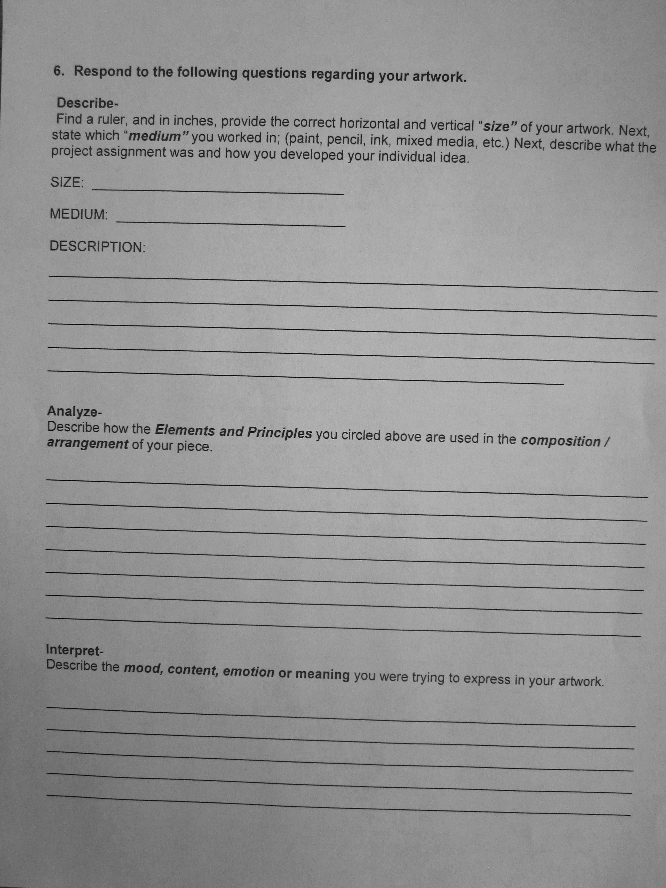
Appendix 3 - AP Student Self & Peer Scoring Rubric
AP Student Self & Peer Scoring Rubric
AP Students Self-Scoring Rubric

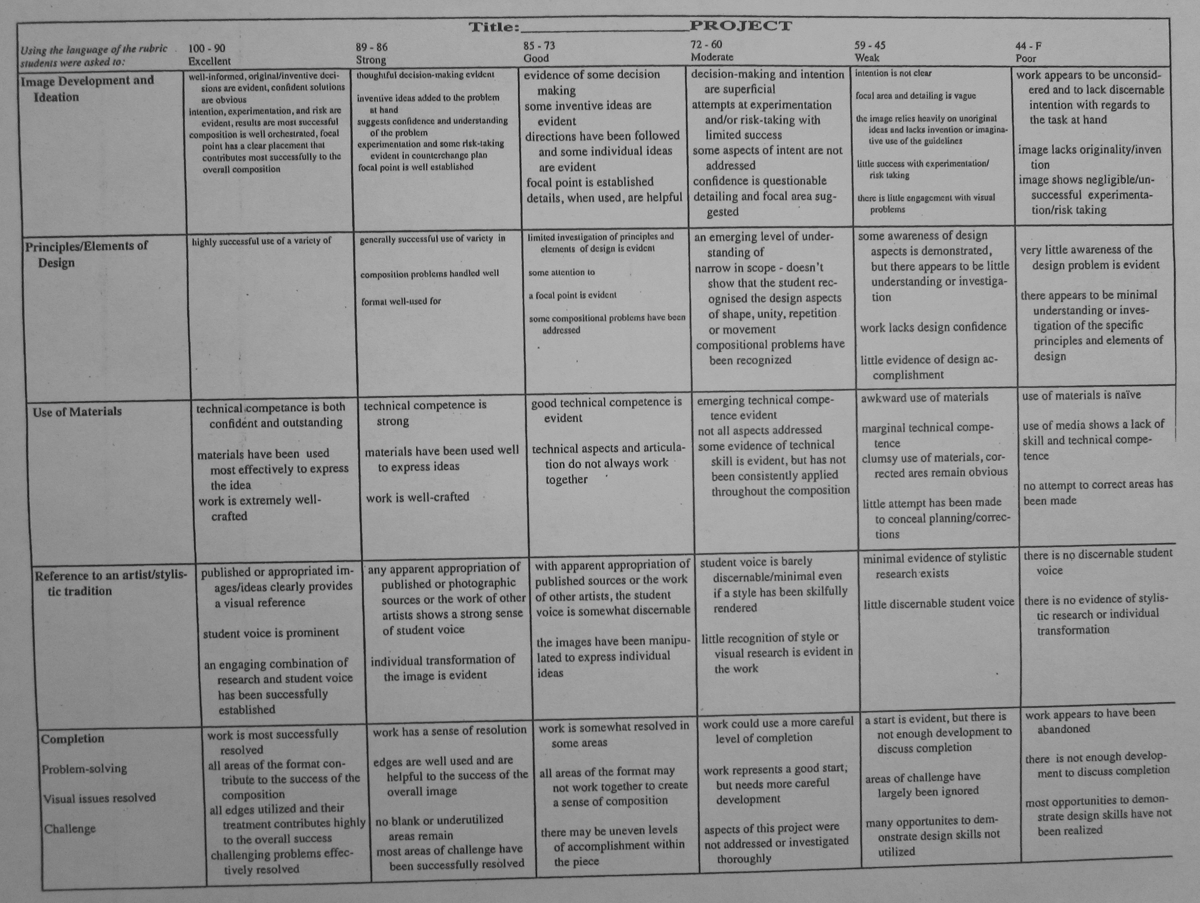
Appendix 4 - Project Proposal Form
Project Proposal Form

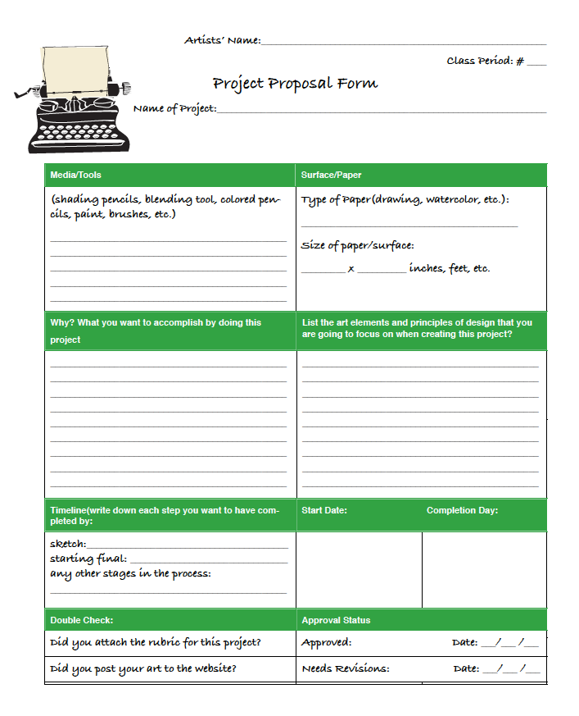

Appendix 5 - AP Studio Art Developing Your Concentration
Developing Your Concentration
Name: _________________________________
Date:___/___/______
Class Period:___

AP Studio Art
Developing Your Concentration

Look up the AP Central web site(there is a link on our class site). Search for the concentration portfolio examples for the portfolio you are interested in(2-D, 3-D, and/or Drawing). Make at least three comments about what a concentration is based on what you find.
1)___________________________________________________________________
2)___________________________________________________________________
3)___________________________________________________________________

Now look up an artist who has a concentration.
Name_________________________________________________________________
List and describe the similarities in this artist’s work for each of the categories below:
- Subject matter__________________________________________________________________________________________________________________________________
- Composition______________________________________________________________________________________________________________________________
- Techniques______________________________________________________________________________________________________________________________
- In this artist’s work, do you notice a strong use of any of the art elements: ( line, shape, form, color, texture, space, value) if so, describe how the element(s) were used.___________________________________________________________________________________________________________________________________________________________________________________________________________________________________________________________________________
- What medium or media and technique do you think this artist used to create his/her pieces? _____________________________________________________________
______________________________________________________________________
______________________________________________________________________
- What common theme(s) did the artist use in his/her work?____________________________________________________________________________________________________________________________________________________________________________________________________________
- Complete the following sentence:
This artist’s concentration is_________________________________________________________________________________________________________________________________________ .

Appendix 6 - Assignment List, from class website
Assignment List
The assignments are listed in categories. Students please pick one assignment from each category as stated in our weekly plans. You can create each piece with any media that fits what you are working on. Make sure to include the media in your project proposal form.
Unity/Variety
X-Ray Overlapping
Take some objects, arrange them, now pretend you have x-ray vision. Draw the objects so that they are overlapping and you can see through one object to the next. Have fun with the composition! For 3-D work with the objects to show the view as many interesting view points that you can come up with.

Work on a surface or form that is different than what you are comfortable with
Find a book that you can take the page out of(not one from the school library), or a magazine, or newspaper, something, now draw on it! Now take another piece of paper and put it on top of the paper you drew on, and draw on it and then reveal the picture behind it! 3-d think how you could do this same assignment, make it a form instead of a flat surface.

Photo Transfer
Print off a photo that you took(using a lazier printer)...ask your teacher for the 'magic' pen and transfer your image...now add to your image. Paint on it, draw on it, rip the paper...do something to change it and make marks on it to make it your style!

Random Objects
Draw for five minutes, set a timer....then stop even if the drawing isn't done, now draw something else for five minutes, this should end up to be a layered drawing. Do the same thing with hand building. Get out your supplies give yourself a limited amount of time and create!

Emphasis
Hug Your Focal Point
Hug your focal point by making curved lines going into it. These could be imaginary lines that you come up with or it could be lines in real life! It's up to you! As long as you have lines that keep the viewers eye going to the focal point that's what matters. The can be done in any media.

Vortex
Create something that is falling into a vortex. This could be things you want to disappear in your life and actually go into a vortex. It could be how you feel sometimes when time is going to fast. Have fun with the vortex and think of what you can show. This is a great assignment to use patterns with!

Extension
Create an image, figure out what you want your focal point to be, now draw radiating lines out from that focal point. Inside those lines draw detail/close-up images that relate to or are of the image you created.

Hint: Think about perspective, patterns, think of art work that has radiating lines coming out of object(graphic designs, etc.).

Street View
Sit on your curb or steps at home and draw what you see. Combine as much of what you see into one picture. Over lapp things, make some areas positive space, negative space, change the texture of things, have fun with it.

Favorite Color with a Different Media
Combine as many medias as you can of your favorite color and create something! Make it just in that color = monochromatic

Create What You Enjoy Doing
What do you spend most of your time on? Create it...if it's painting, playing video games, working on cars, taking care of family members, etc. Create it and show how you feel about it. (of course keep it appropriate)

Poem
Find a piece of paper that has text on it(not text images, but words on it). Circle the words in order that you want your poem to reveal itself to your audience. You can add words or images between the words if you need to. Find a creative way to link these words, so that people can read the poem and see what you are trying to communicate with your audience.

Artistic Weapon
What power is inside your favorite tool as an artist? Show your audience the power that a pen, paint brush, airbrush, etc. can have? If it could talk what would it say? What would it do? Would it change the world? Etc.

Rhythm
Two in One
Create a detailed drawing of a flower, leaf...something organic....now add another drawing in the background of a shadow(this is all dark), after that shade your back ground, and figure out how to combine all the pieces(think about tone, value, patterns, etc.).

Transform a Hand
What can you turn a hand into? Can it become a mountain, a river, etc. What power do hands have to change the world by putting them to work? Draw what power hands have and morph it into what hands have the power do to.

Let a Song Inspire You
Create your favorite song, this can be abstract or realistic.

Balance
Paint Sample Collage
Get paint samples and make a collage out of them!

Tape Watercolor Painting or Drawing
Get some painters tape from the teacher. Tape off sections of your paper(you can use watercolor paper, drawing paper, etc.). Now draw something on it and over it! When you are done with creating your image, take the tape off your drawing and see what you have left! It will let your viewer make the connections between the spaces where the tape was.

I hate this piece of my art!
Do you have a drawing you hate? Maybe it's a still life, a landscape, something we did in class...well take it and cut it up and layer it to create juxtaposition in your art!

Ripped and Shaded Pictures
Rip paper apart and shade with it. Put the ripped pieces of paper down, shade on the ripped edge so you create a different type of line. Make this into a drawing.

5 Things
Look in your backpack, in your room, in your car, some where...find at least five things and put them together. If you want to bring the five things to school you can. Try to arrange the things so they are overlapping each other in some way and draw the shadows!

Contrast
Narrative
What are the contradictions in your life? What things just confuse you that don't make sense in life? Draw those two things. It maybe something that is ironic...the fat person drinking a giant soda, a poor or hungry person walking outside a restaurant where everyone inside is eating, etc. I know you see things like this in your life, or maybe you hear things like this in songs, what just doesn't make sense to you and you want to talk about in your art!

Scratch Board
Get a piece of it from your teacher and try to do something using scratch board. If you mess up, get creative to cover it up!

Light
What's your favorite type of lighting? Morning, daytime, when the sun peaks through the clouds, night time, etc.? Show it! This will be a challenge, you can either show it using a monochromatic(one color, pencils, charcoal, etc.) medium or colors. You pick!

Change Your Point of View
Two drawings...you can put these side by side. The goal is to create a drawing, look at it, and then draw the same thing from a different perspective.

Wrap An Object
Wrap an object up and draw it! -or- Recreate what you see in another media to give it form and shape.

Repetition
Shopping Cart
Draw a shopping cart....maybe there is one left on the road, maybe you can go to the grocery store...find a unique view or layer multiple views of the shopping cart.

Lost and Found
Create something, but don't show us the whole thing...leave some space between and let the viewers eyes connect the spaces between(this seems like an illusion but it works). If you have a hard time with this, draw the whole thing, then put a piece of tracing paper over it and just draw the parts of the image that you think are most important for giving the viewing hints of what you are drawing.

Bleed
What would you risk your life for? Draw it and make the image bleed(not real blood, but make the image run with either ink or paint...you could use pencil, get creative). Show what you care about and think of ways you can make the running or the pigment(paint, ink, etc.) add to the meaning of your work.

Childhood Drawing
Find an object from your childhood(a toy, blanket, etc.). Maybe you have a picture of it or a younger sibling now uses it. Find a unique way to draw it(repeat the object, draw it up close, draw it big, add emotion to it that you associate with that object).

Proportion/Scale
Object on a Mirror
Take an object and put it on the mirror. Draw it! If that was too easy...add more objects!

Movement
Draw 8 different poses...overlap them on each other so it looks like the person is moving. This could be of a person dancing, playing a sport, sitting, walking, running, something...make it interesting. Hint: the more you over lap the image the more it get's interesting. You could use charcoal, three colors that go well together, pencil, crayon, marker, etc. You might want to make this BIG!

Worn Out Jeans
Draw a pair of worn out jeans...hang the jeans, put them in a pile, find a different perspective. Draw the folds in the cloth...you can do this in graphite or color...it's up to you.

Face Through a Glass
Take an image of yourself looking through a glass with water in it and then draw what you see!

Sliced Bread
Find a fun perspective to show a slice of bread. You will focus on fore softening(making objects look closure and farther apart depending on where they are in space). Talk with Mrs. Lyon about this one to make sure you start on the right track.

Draw What You See in a Mirror
Put an object in front of a mirror and draw it. Don't worry to much about rendering(making it look exactly how it is), let the confusion of the image in the mirror be okay, it might end up being an amazing abstract piece.

Train Station
Visit the train station down at Union Station and have fun trying to find a different perspective, draw close up, far away, have fun with it and show what you know about shading and light. It might help to take a picture of your image to preserve the right type of lighting you want.

Nature Small
Find something in nature that is big and make a small drawing/painting of it.

Figure/Ground Relationships
Panorama
If you can, take a panorama picture with a camera...now draw it. Feel free to play around with perspective, what you want to focus on or make larger or smaller. How do you share a 180 or 360 view through your art with the viewer?

Pop-Up
Create a pop up book or card! Make sure to include a fore ground, middle ground, and background. Hint: Think of what you could visually tell a story about with this assignment, have fun!

Erased Silhouette
Draw a silhouette of a human in graphite...now erase it, but use lines going all in one direction, either vertical, horizontal...think of how it will effect your drawing. This might look like a person in the rain, blurred from moving, etc. Get creative with the idea of erasing! Make sure to clean your eraser off as you erase and make the figure dark enough to blur the graphite, but not to dark so that it won't erase. Hint: Experiment with graphite pressure and different types of paper.

Conceptual, Perceptual & Expressive Development
Mouse Trap
Find a mouse trap and draw it! Draw it in a glass of water, draw it with something in it....have fun with the mouse trap....maybe the mouse trap is a metaphor of what is trapping you in life.

Family History
Create something that relates to your family history, try to show the viewer the relation.

Clean Up!
If you could clean something up in the world, get ride of it what would it be? How would you clean it up?(with a big broom, thrown into space, etc.)

Blur Your Outside Lines
Draw something in detail, but blue the outside lines...as if you view is fading away. The areas that are in focus/detailed should be where you want your viewers eyes to go.

Take a Risk!
Draw something that you would never draw or try a technique that you haven't done yet. Try to draw something, even if it doesn't turn out perfect, that's okay, the goal here is to get out of your comfort zone and try something different.

Phone Pictures
Look through the pictures on your phone. Find one picture that has a particular memory that draw that picture, but show your viewer how the memory makes you feel(transform this picture into more than what it is....more how you feel).

Predict the Future
What do you think will happen in the future and why? Show it! Show the viewer your process of thinking and how the ideas of the future relate to one another.

Technical Challenge
Ink Pen
Find an ink pen. This is one of those old school pens that you have to dip in the ink and then you can paint with. Experiment with different types of lines and see if you can get different tones of gray out of the ink.

Something Different
Paint or draw on shoes, a shirt, pants, a phone, something that is not paper! Have fun with it, think about the shape of the object you are working on. For 3-D works you could create something with a different media than we have used, this how you could reuse something and turn it into a different art function.

Work with the Media You Hate
Think of the media you hate the most....is it pencil, paint, colored pencil, charcoal, pastels....well that is what you have to work with. Now draw whatever you want, preferably something you like so that you are at least dealing with one thing you like.

Object in a Glass of Water
Take an object, put it in a glass of water and draw it! Think of how to draw the water and how to show that the object has changed when it is out of the water and when it is in the water. Find a view point on this that you think is interesting to the viewer and not just a common view that one might have(great creative).

Line Paper
Yup, that's right. Get out a piece of lined school paper with all those light blue lines on it...now draw something on it...(think about how you can use the lines to work from or add to for your art).

Grid Drawing
Use a grid to take a smaller image and make it larger...challenge yourself.

Complimentary
Pick your favorite color, find the compliment of that color(opposite color on the color wheel). Now use those two colors to create something.

Stomp It Out!
Create something that you wish you could stomp out of your life and do it! Draw it, paint it, etc.

Scribble Something
Scribble sometime on your paper, look at it, turn it into something, do this again until to create something that you want to spend two weeks working on to create a final project.

Shrink and Enlarge
Draw/paint something that is big in real life, but draw it small
Find something that is really small and draw/paint it really big
This will count for 2 assignments

Appendix 7 - Terms to Know
Terms to Know

Terms You Need to Know
This is a list of terms that we will use in class. There is a language with every subject area and some of the words overlap and some are unique to a subject matter. In order to speak the visual language of art we all need to be on the same page. So this is your page to learn, be on the same page, learn these words, you will be accountable for it. Thank you for taking the time to memorize these words.

Visit this Wiki Page below to see some of the definitions:

http://en.wikipedia.org/wiki/Design_elements_and_principles

A visual slideshow about art principle and elements of design:

http://www.slideshare.net/kpikuet/elements-and-principles-of-art-presentation

Did you hear a term and need to look it up? Check out this site below:

http://www.artlex.com

Teacher References/Resources

AP Central. apcentral.collegeboard.com
AP Studio Art Post. New York: The College Board, 2013.

